Define the following terms in the context of Bayesian Decision Theory:

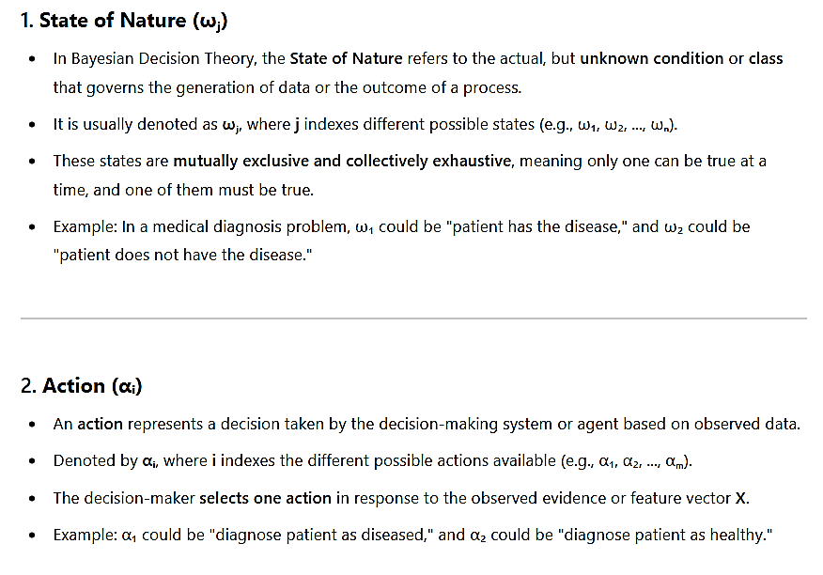

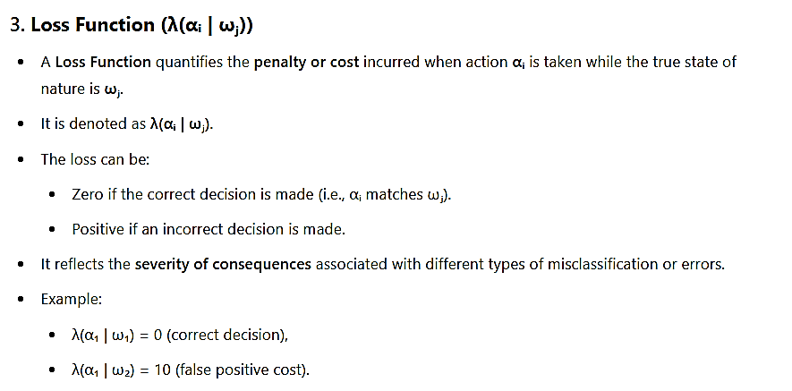

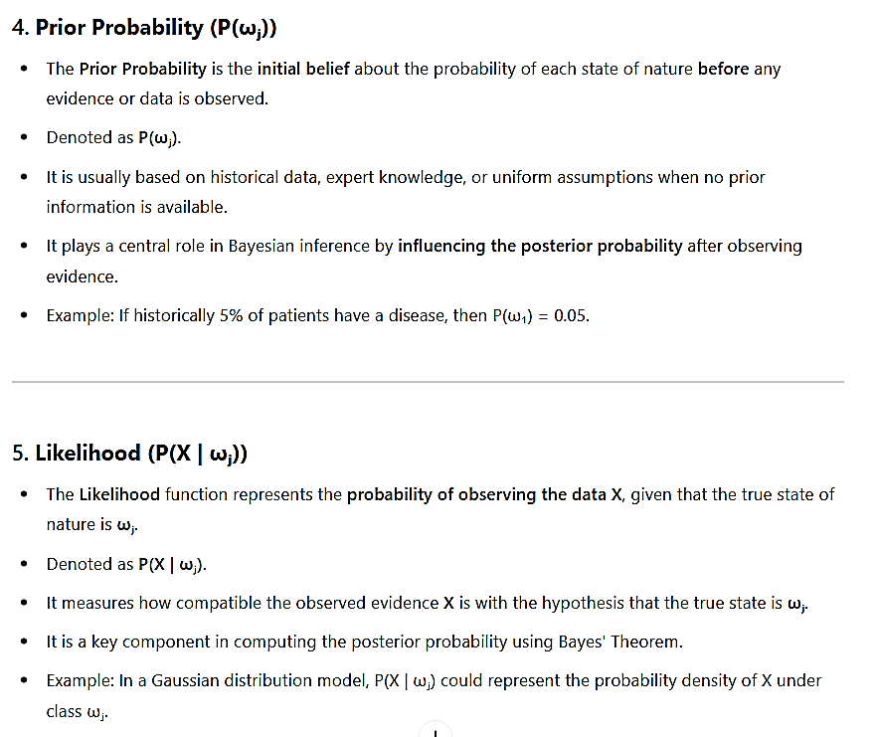

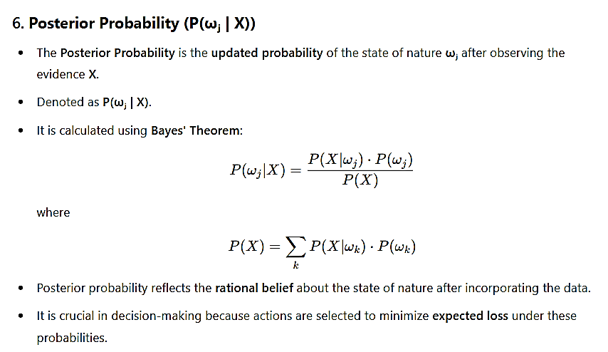

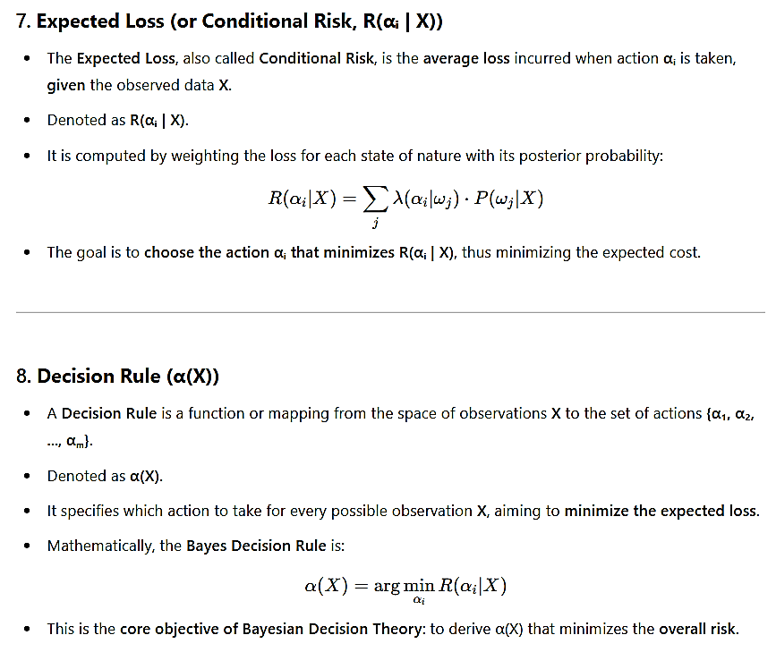

**🔰 Describe the role of the loss function in the decision-making process within the Bayesian framework. Why is it important to define a loss function?**

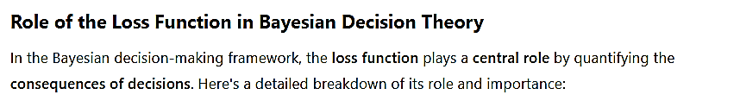

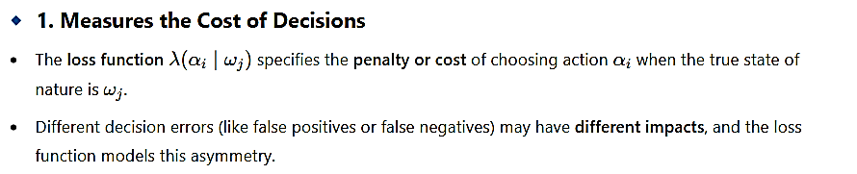

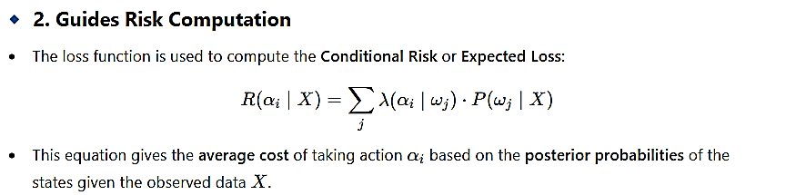

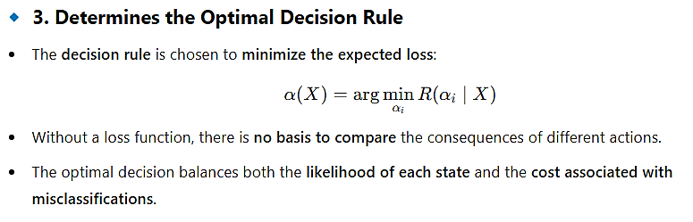

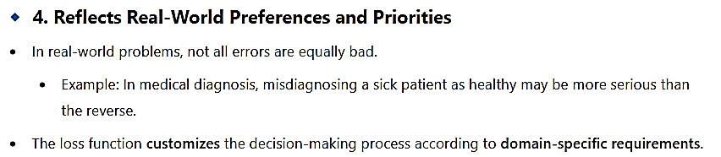

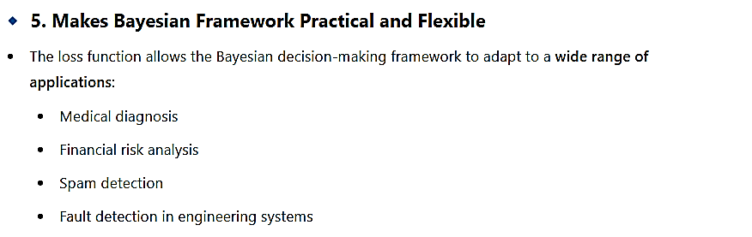

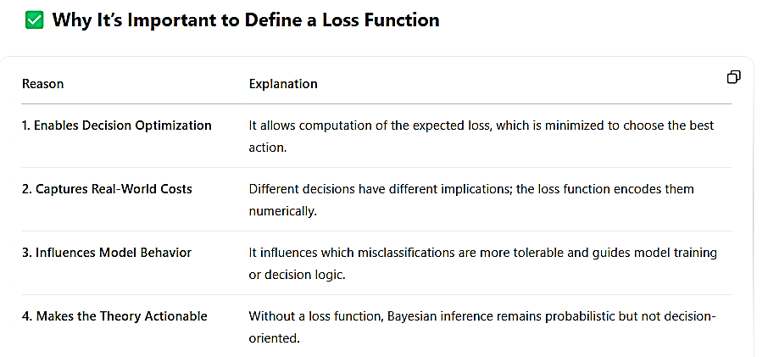

**🔰Derive the expression for conditional risk and explain how it is minimized in Bayesian decision theory.**

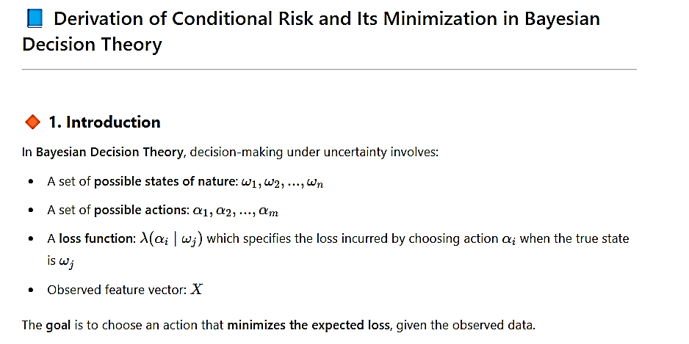

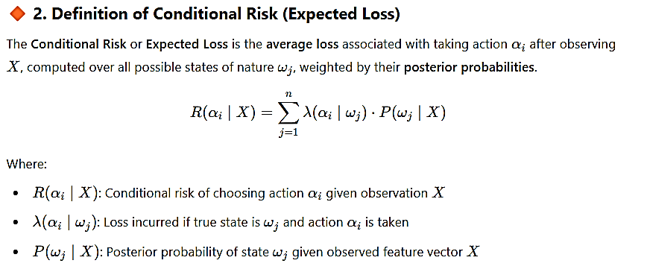

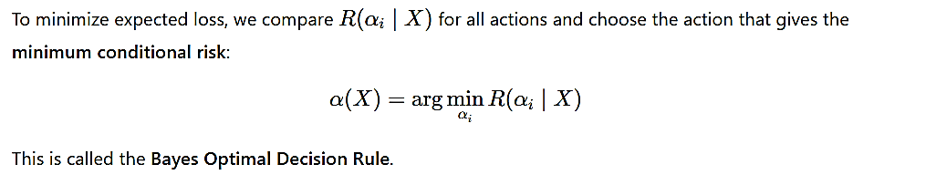

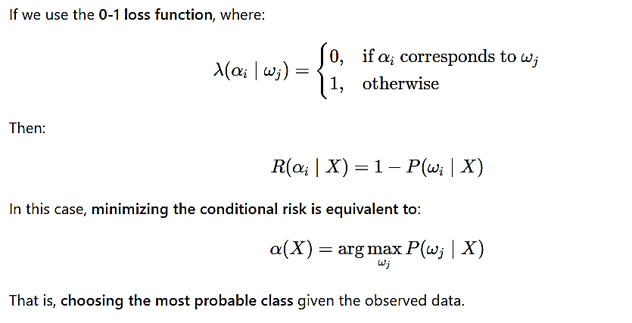

**🔰Imagine a spam email detection system. What could be the two states of nature? What are the possible actions the system can take? How might a loss function be defined for this problem?**

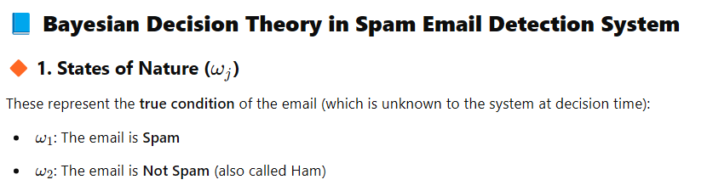

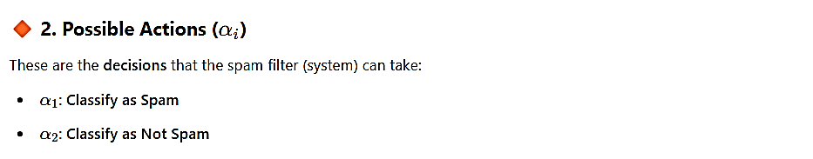

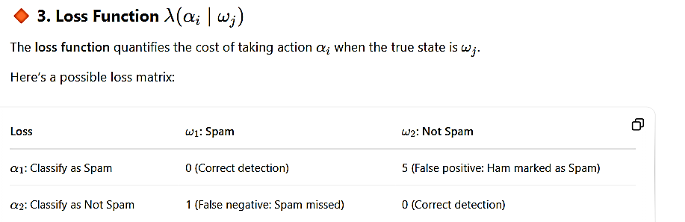

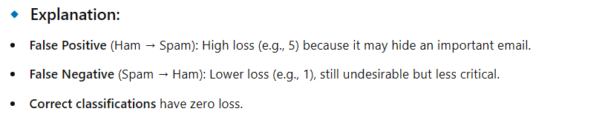

In a spam detection system:

* The goal is to minimize expected loss using posterior probabilities and this loss matrix.
* Bayesian Decision Theory helps choose the action (spam or not) that balances the risk of misclassification with the consequences (losses) of each type of error.

**🔰In a medical diagnosis scenario, identify what could represent the states of nature, the actions, and potential components of the feature vector X. Briefly describe what a loss function might represent in this context.**

